# **Create a virtual environment**

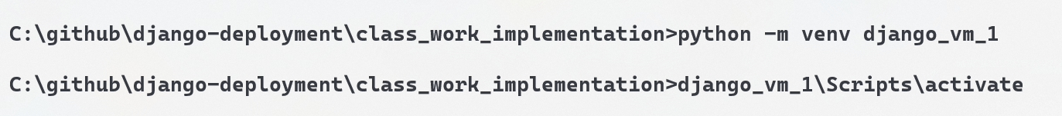

# **Install Django**

# **Creating a Django Project**

Creating a project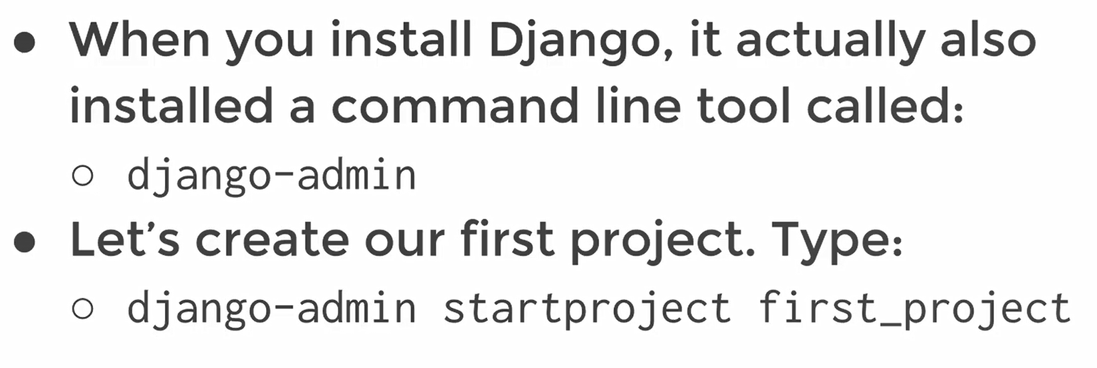   
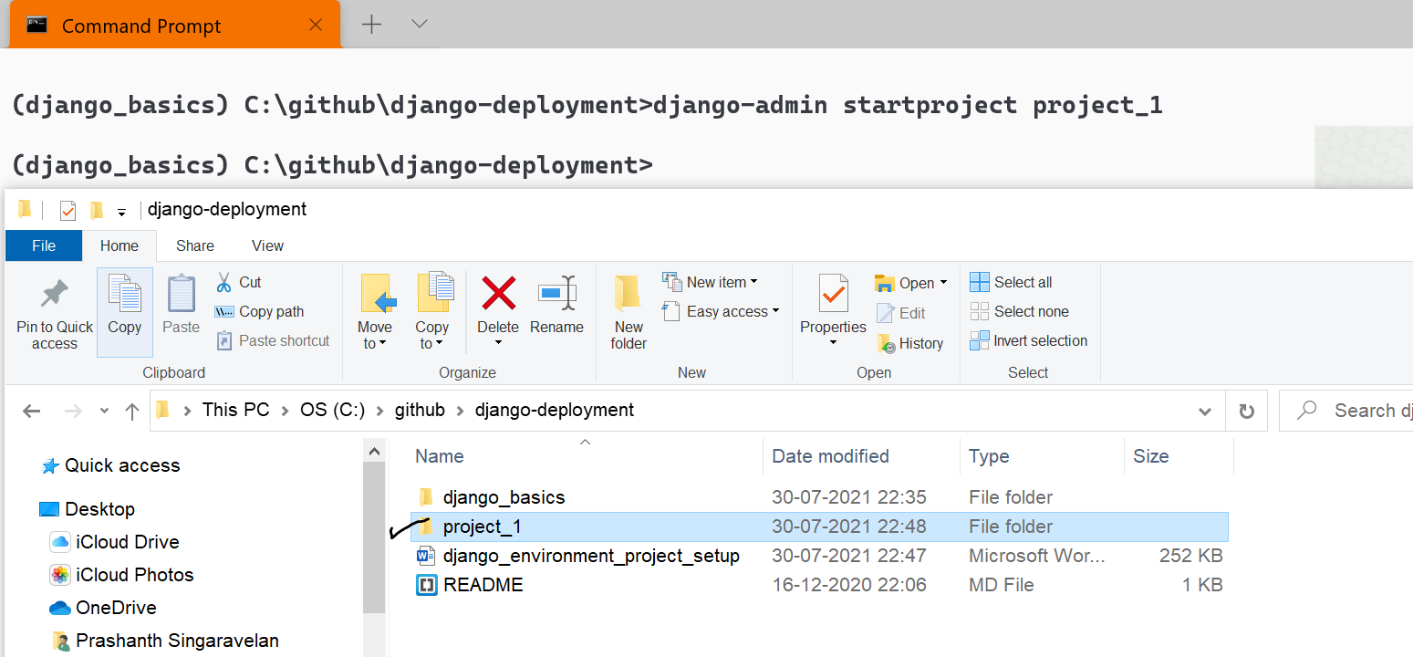



Exploring Project file structure  
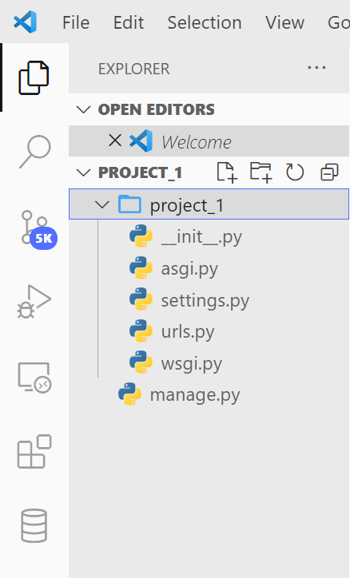

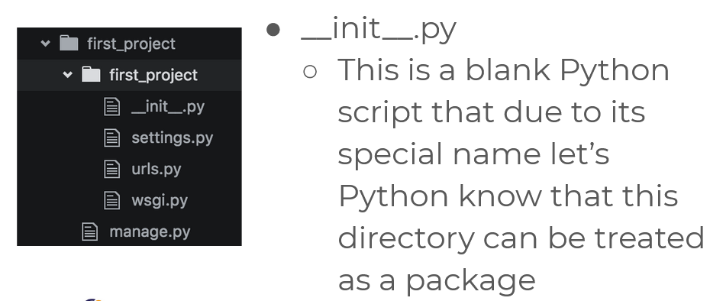

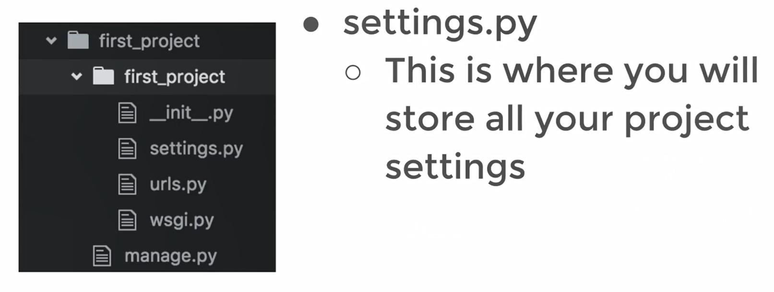

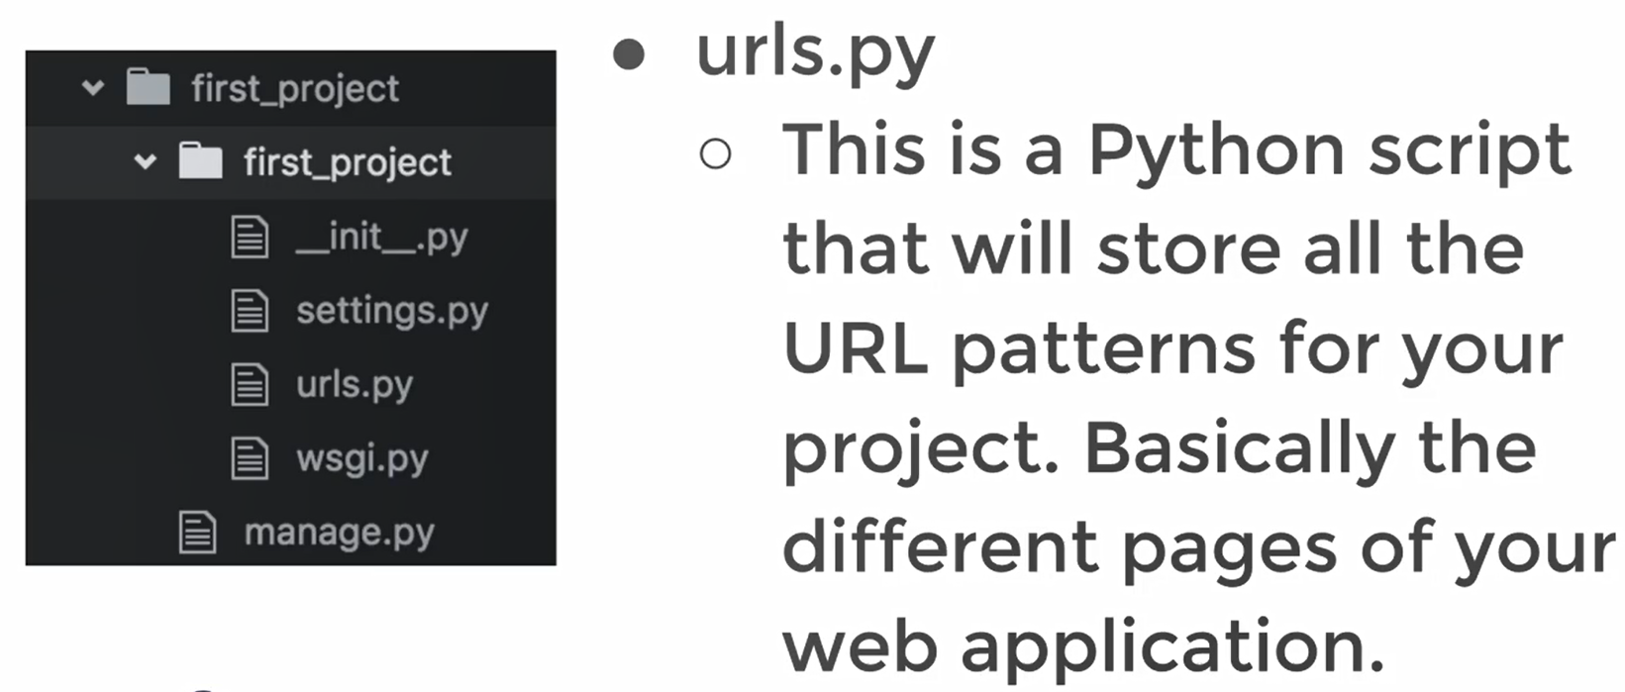

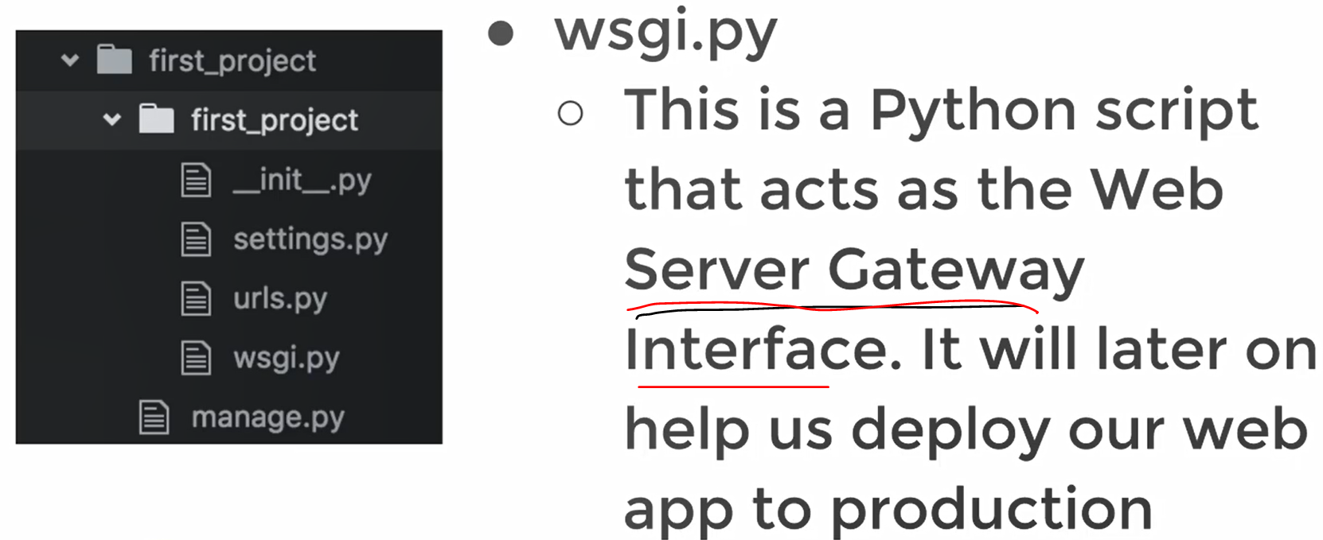

For production purpose of this website in some online servers.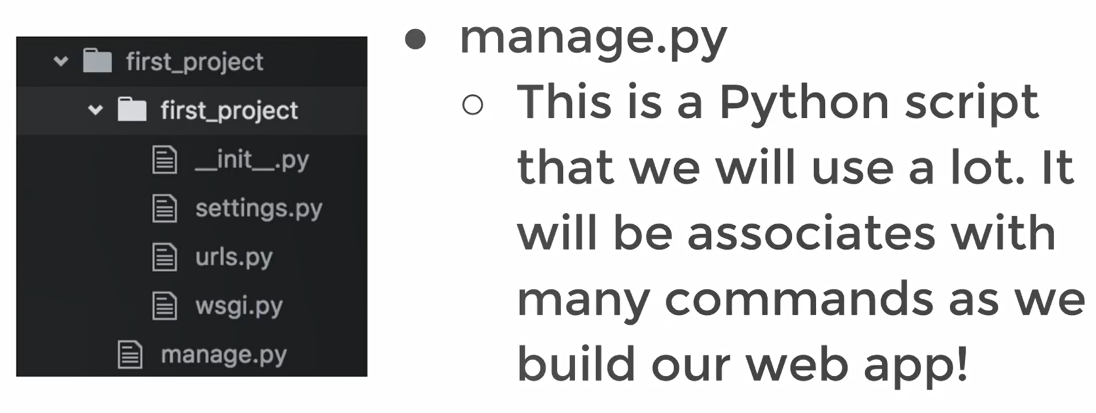

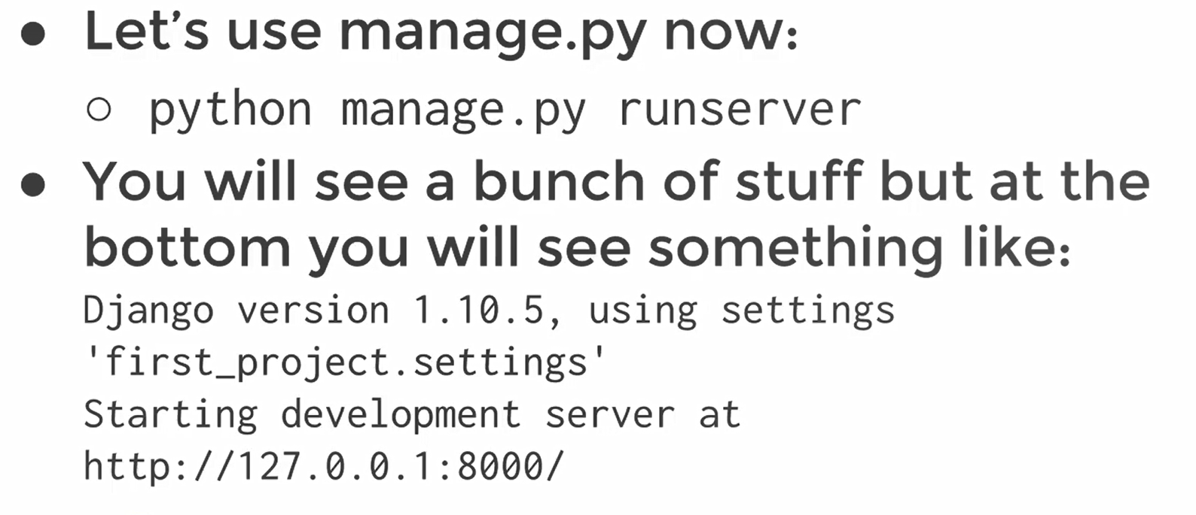

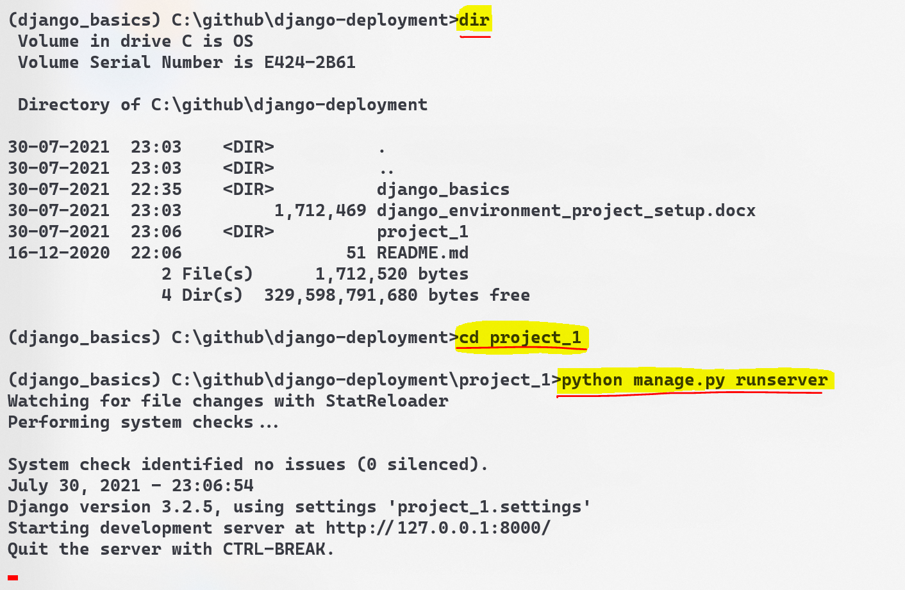

**Django application**  
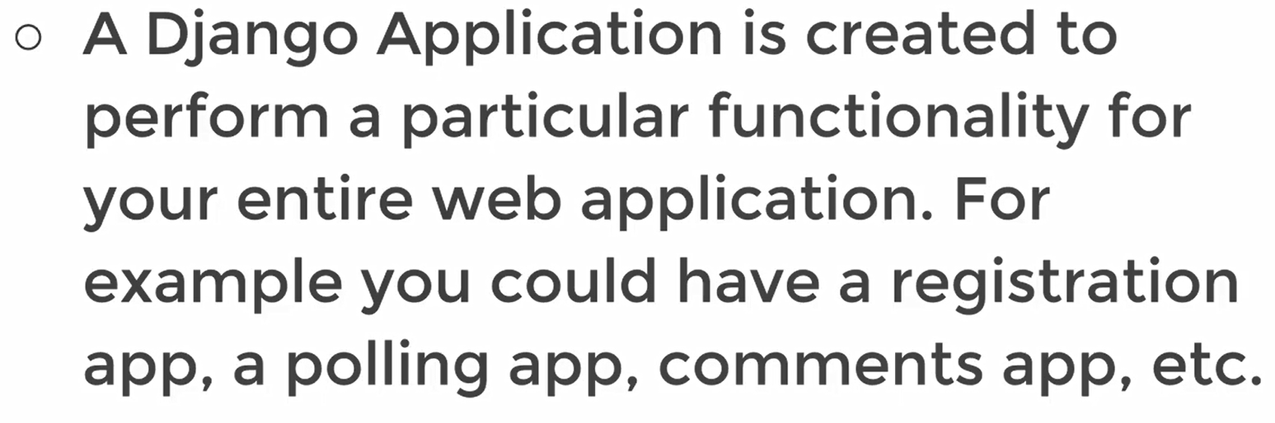  
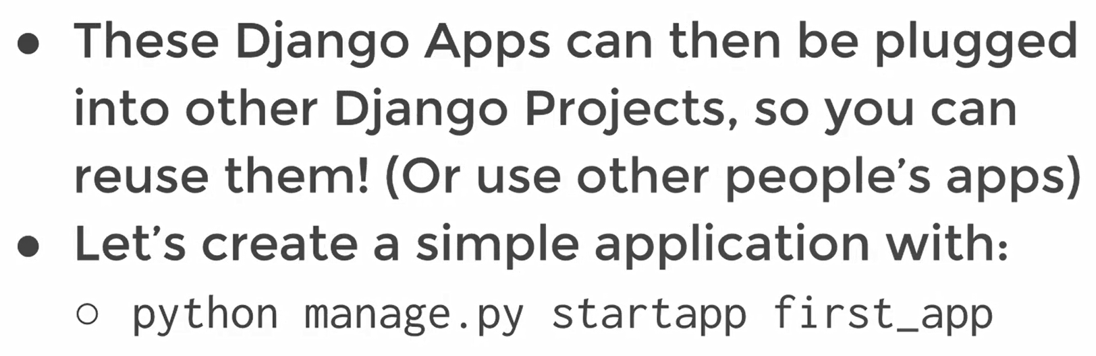 **Creating Django application**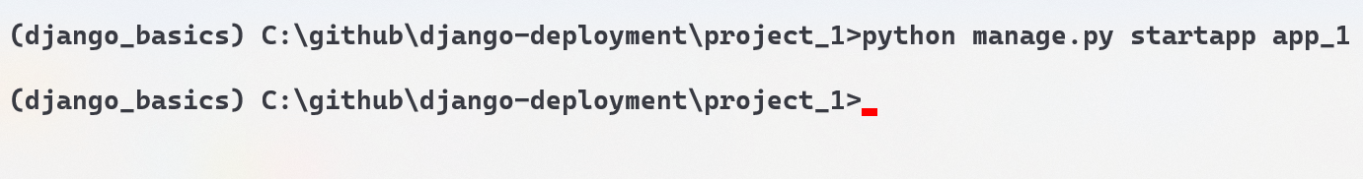

We can give any app name. Before we explored project, now we are going to explore app.

# **Exploring the Django app structure**

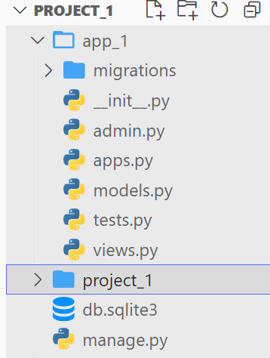

# **Add the created application to your project**

Lets see how it works

If the sever runs without any issues, then there will be no error after inserting the application into the project.